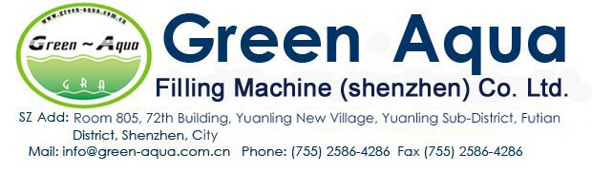
150BPH（5gallon）Full Filling Line water factory
Character:
Turnkey Package solutions for Water Factory
Suitable 3/5gallon Round bottle
Schneider electrical Components+Omron PLC
All stainless steel materials for the line
3T/H RO Plant+ Automatic 150BPH 5gallon Filling Production Line
Name | Item | Qty
Ro water purification machine | GRA-1000I(3T/H) | 1 pcs
Water softener |  | 1pcs
CIP System |  | 1pcs
Ozone system | 15G/H | 1 pcs
Water tank (SUS304) | 3T | 1 pcs
UV System | 20W | 1pcs
150BPH 5gallon Water Filling Line
Automatic Decapping Machine | GRA-BG(150BPH) | 1pcs
Automatic Outside Brushing Machine | GRA-WX(150BPH) | 1 pcs
Automatic Washing/Filling/Capper Machine | GRA100/J(150BPH) | 1 pcs
Washing /Feeding cap machine | GRA-XG(150BPH) | 1 pcs
LED Light inspection | GRA-DJ(150BPH) | 1 pcs
Heating Label shrinking Film machine | GRA-RS(150BPH) | 1 pcs
Full SUS304 Dynamic Conveyor (Stainless steel frame, rails, brackets) | SUS304 | 7M
No power slider | SUS304 | 4M
Air compressor with storage tank |  | 1pcs
Semi-5gallon Blowing Machine
Infrared heating machine |  | 1pcs
High air compressor | 1.0M3/30kg | 1pcs
Air Dryer | 1.0M3/30kg | 1pcs
Air filter | 1.0M3/30kg | 2pcs
Bottle mold(5gallon) | 45#steel | 1pcs
High pressure Pipes etc |  | 1 lot

