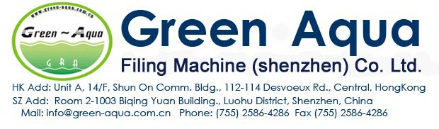
2000BPH(for 500ml bottle) Isobaric Gas beverage Filling Line Quotation
Pure Water Treatment System
1 | Pure Water Treatment Machine | GRA-1000I(2000L/H) | 1pcs
2 | CIP Cleaning system |  | 1pcs
3 | Water tanks(SUS304) | 2T | 2pcs
4 | Ozone System | 6G | 1pcs
5 | UV System | 40W | 1pcs
Beverage Mixing System
1 | Preparation tank(hot/cold, double layer ) | 1000L,SUS304 | 2pcs
2 | Melting sugar pot | DHT-350 | 1pcs
3 | Syrup filter | TML-500 | 1pcs
4 | Syrup cooler |  | 1pcs
5 | Beverage storage tank(sus304) | 2000L | 2pcs
6 | Beverage pump | 2T | 3pcs
7 | Cold water tank+chilling machine | 2000L | 1pcs
8 | Co2 Filter |  | 1pcs
9 | Beverage mixing machine |  | 1pcs
10 | CIP Cleaning system | CIP-500(semi) | 1pcs
11 | Pipes etc | SUS304 | 1lot
12 | Air compressor |  | 1pcs
Beverage Automatic Washing/Filling/Capping line
1 | Air conveyor |  | 10M
2 | Isobaric Washing/Filling/Capping Machine: | GRAD12-12-5 | 1pcs:
2 | Bottle change parts | 0.5L | 1pcs
3 | Lift cap feeding machine |  | 1pcs
4 | On line cap sterilization machine | SUS304 | 1pcs
5 | Warm bottle machine | SUS304 | 1pcs
6 | Bottle body drying machine | 5.5KW | 1pcs
7 | Automatic laser coding machine | 10w | 1pcs
8 | Automatic labeling machine | GRA-TB(150) | 1pcs
9 | Automatic Shrink Wrapping machine | GRA-MB(150) | 1pcs
10 | Extra air conveyor |  | 20meter
11 | Conveyor |  | 20meter
Automatic Bottle Blower
1 | Blowing Machine | GRA-A2 | 1pcs
2 | Auto Preform loader machine |  | 1pcs
3 | High pressure air compressor(hengda brand) | 2.4M3/30KG | 1pcs
4 | Low pressure air compressor (hengda brand) | 1.6M3/10KG | 1pcs
5 | Air dryer | 2.0M3/30KG | 1pcs
6 | Air filter | 2.0/30KG | 1pcs
7 | Air Tank | 0.6/30KG | 1pcs
8 | Water chiller | 3HP | 1pcs
9 | Blowing mould(45#steel,500ml) | 2cavity | 1pcs
