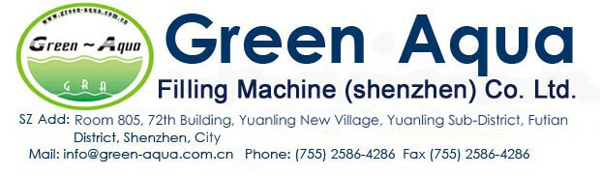
2500BPH（0.5L）Full Filling Line water factory
Character:
Turnkey Package solutions for Water Factory
Monobloc current Design for filling machine
Free change from 250-1500ml bottle

NO | Machine Name | Capacity | Qty
1 | 3000L/H RO Water Machine | GRA-1000I(3000L/H) | 1pcs
2 | CIP Cleaning system |  | 1pcs
3 | UV System | 87W | 1pcs
4 | Ozone generator | 15G/H | 1pcs
5 | Water tank | 3000L/H,SUS304 | 1pcs
Automatic Washing/Filling/Capping line:2500BPH For 500ml Bottle
1 | Air Conveyor System: |  | 2M
2 | Washing/Filling/Capping Machine | GRA8-8-3 | 1pcs
 | Bottle change parts | 0.5L | 1pcs
 | Product conveyors |  | 2m
3 | Feeding cap&On line cap sterilization |  | 1pcs
4 | Light Inspection System: | GRADG-1 | 1pcs
5 | Bottle Body Drying Machine | GRACG-1 | 1pcs
6 | Automatic shrinking Heating Labeling Machine | GRA-TB(150) | 1pcs
 | Bottle change parts | 0.5l | 1pcs
7 | Laser Printer | 10W | 1pcs
8 | Automatic shrinking wrapping machine
 | Automatic shrinking wrapping machine with air compressor | GRA-MB(150) | 1set
 | Bottle change parts | 0.5L | 1pcs
9 | Extra conveyors | 20meters
10 | Extra air conveyor | 10meters
11 | Air Compressor for Filling machine |  | 1pcs
Full Electric Automatic Blowing Machine:GRA-A2,3000BPH bottle for 500ml bottle
1 | Servo Automatic blow machine | 1pcs | 2 cavities
2 | Preform unscrambler and lifting machine | 1pcs | By servo control
3 | Win Industrial Chilling water machine:5HP | 1pcs | 3HP, LJ-05wi
4 | Bottle mold(0.5l,2cavities) | 1pcs | Aluminum
5 | High pressure Air Compressor(3M3/40bar) | 1pcs | Hengda brand
6 | High Pressure air storage tank:1m3/40bar | 1pcs | SUS304
7 | High pressure pre filter | 1pcs
8 | Post high pressure filter | 1pcs
9 | High pressure precision filter | 1pcs
10 | High pressure active carbon filter | 1pcs
