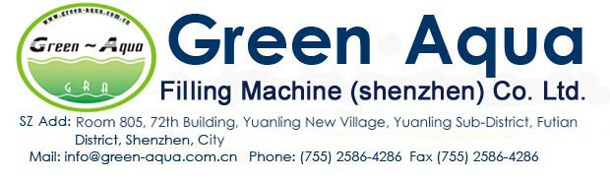
10000BPH（0.5L）Full Filling Line water factory
Character:
Turnkey Package solutions for Water Factory
All Machines are Automatic
Monobloc current Design for filling machine
Free change from 250-1500ml bottle
NO | Machine Name |  | Item | Qty
1 | 5000L/H RO Water Machine |  | GRA-1000I(5000L/H) | 1pcs
2 | CIP Cleaning system |  |  | 1pcs
3 | UV System |  | 100W | 1pcs
4 | Ozone system |  | 32G/H | 1pcs
5 | Water tank |  | 5000L/H,SUS304 | 1pcs
Automatic Water Filling Line
1 | Air Conveyor System: including sensors,motors |  |  | 20M
2 | Washing/Filling/Capping Machine |  | GRA24-24-8 | 1pcs
 | Bottle change parts |  | 0.5L | 1pcs
3 | Automatic feeding cap Device |  |  | 1pcs
 | One line cap sterilization device(tank+pump) |  |  | 1pcs
4 | Bottle body dryer |  | 5.5KW | 2pcs
5 | Automatic Heating Shrink labeling machine by double driving system
5,1 | Automatic label wrapper |  | GRA-TB(150) | 1pcs
5,2 | Label shrink tunnel |  |  | 1pcs
5,3 | Steam generator(18KW) |  |  | 1pcs
6 | Automatic Laser CO2 Printer |  | 30W | 1pcs
7 | Linear Automatic Heating shrinking wrapper
7.1 | Automatic film wrapper |  | GRA-LMB(150) | 1pcs
 | Heating shrink tunnel |  |  | 1pcs
7 | Air Compressor for Filling machine&shrink wrapper |  |  | 1pcs
8 | Conveyer |  |  | 20m
6Cavities Servo Automatic Blowing Machine(Full Electric)
1 | Servo Automatic blow machine | GRA-A6 |  | 1pcs
2 | Preform unscrambler and lifting machine |  |  | 1pcs
3 | Window Industrial Chilling water machine | 5HP, LJ-05wi |  | 1pcs
4 | Bottle mold(500ml,4cavities) | Aluminium |  | 1pcs
5 | High pressure Air compressor | 3M3/40bar,Hengda brand |  | 2pcs
6 | High Pressure air storage tank: | 1M3/40KG |  | 1pcs
7 | Air filters |  |  | 4pcs
8 | Air drying machine |  |  | 1pcs
